**AP Biology Summer Blog**

**setup directions**

1. Navigate to your teacher’s AP Biology page on their website and click the link that says Period # Summer Blogs (**use your appropriate period #**)

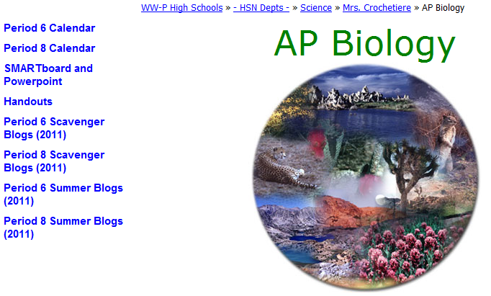

1. Login using your network username and password. Create a security question and answer.

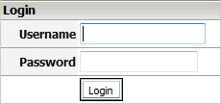 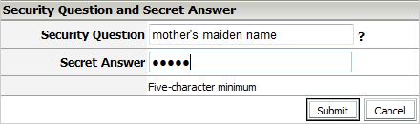

1. Using the link bar on the top, hover over **Page Properties** 🡪 **New Page** 🡪 and then click on **Blog Page**

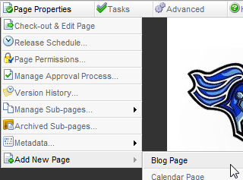



1. Add Blog Page
   1. Type your name in the Title box.
   2. Press the blue arrow.
   3. Click “**Create Page**”
   4. Click on your name on the left side of the page

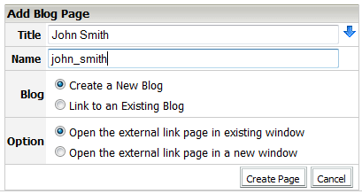 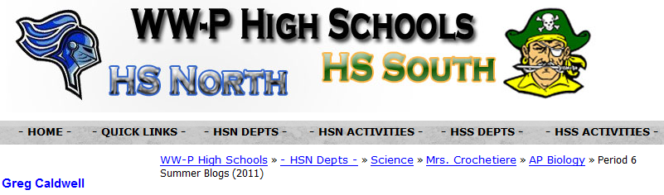

**John Smith**

* 1. Blog setup Click on the  link
  2. Select the  tab
  3. Select the  tab
  4. Uncheck all boxes except administration and Content Alert Description. Pause for a second after each click and wait for the page to refresh and apply your changes.

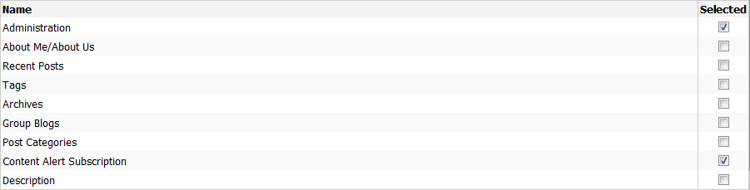

1. Configure Blog Security
   1. Select the  tab and then the  tab.
   2. Click the plus sign next to your name “browsers”  (should be the last one in the list)
   3. Press the  button.
   4. Find HSN Staff and press the  button.
   5. Find HSN Students and press the  button.
   6. Press the  button.
   7. The window should close and the screen should refresh. You should now see this below yourname “browsers.” If you do not, repeat steps a-f until you do. The security window can be kind of finicky.



1. Posting
   1. You must be logged in.
   2. Navigate to your blog
   3. Press under blog administration.



* 1. Enter your Post title and type text in the body. Use formatting tools as needed.
  2. Press  when ready.

1. Uploading images using SharpSchool Image Manager
   1. Click the Image manager button in the editor bar.

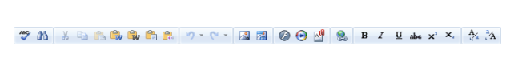

* 1. Double click the hcrochetiere folder to open it.
  2. Double click the StudentBlog Images folder to open it.
  3. Select the "Upload" button. **(Reduce the clutter! Make sure 'hcrochetiere' is showing before you upload.)**

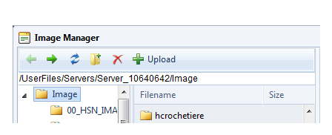

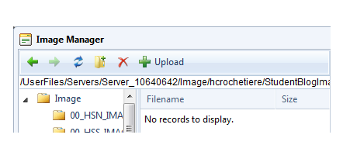



* 1. Browse for your files (the Select Button) and then upload them.

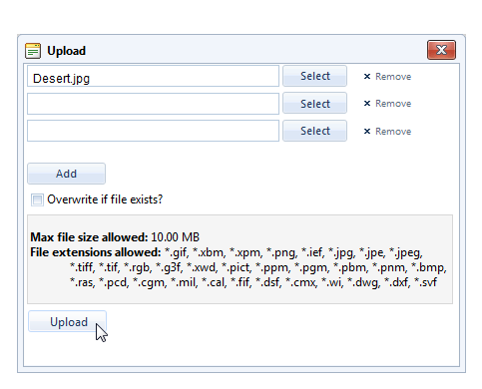



1. Inserting Images Using SharpSchool Image Manager
   1. Open Image manager if not already open by clicking the Image manager button in the editor bar.



* 1. Browse for the desired file in the folder and select it.
  2. Press the Properties tab.
  3. Type in a description into the Alt Text area for handicapped users (required).
  4. Press "Insert".
  5. The image appears in your page.
  6. You may need to drag the resize handles if the image is large.

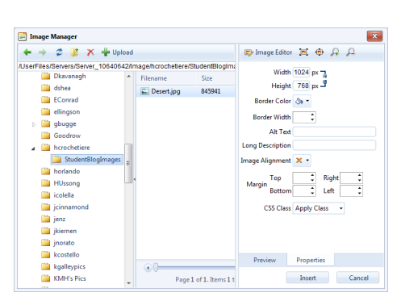

Picture of Desert

