Before we end the year, let’s try to see how well we have trained our minds this past school year with some fun puzzles for any age!! Let’s see how you do with these!

The Trickiest Sentence Ever
This little brain teaser is simply amazing. If a teacher presents this to a class of 30, maybe at best only 1 or 2 students will get this correct. Doesn’t matter what grade or level of schooling either!
—————————

Count the number of “F”s in the following sentence. Take your time, but only read through once.

FINISHED FILES ARE THE RESULT OF YEARS OF SCIENTIFIC STUDY
COMBINED WITH THE EXPERIENCE OF YEARS.

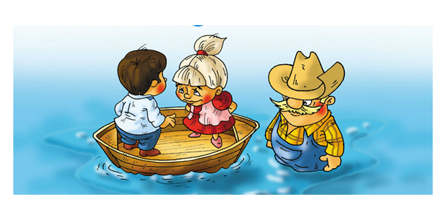
River Crossing Puzzle

A farmer, his son and daughter, and their pets need to cross a river. The pets are an aggressive dog, 2 hamsters, & 2 rabbits. There is a small two-seater boat they can use (no a pet can’t sit on one of their laps!. All 3 people know how to use the boat, but none of the animals can.

1. If the farmer is not around, the aggressive dog will bite everyone and everything.
2. If the daughter is not around, the son will tease the rabbits.
3. If the son is not around, the daughter will tease the hamsters.
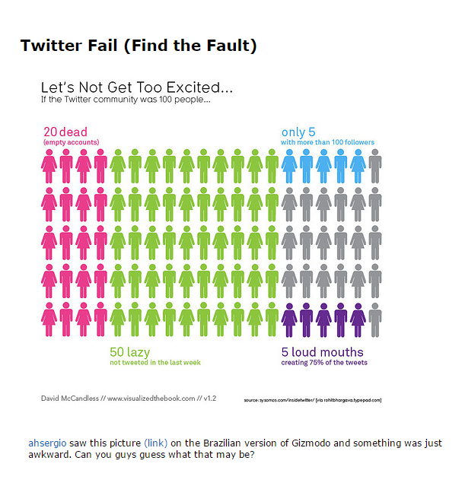
4. The hamsters and rabbits get along fine with each other.

